**MECH9420 Lab 1 Notes**

This lab was a quick demonstration of how to make a carbon fibre composite sheet.

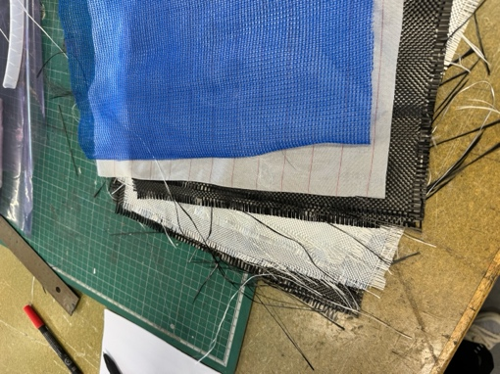Carbon Fibre Composite Makeup:

* 2x 0.2mm Carbon Fibre Sheet
* 4x 0.2mm Glass Fibre Sheet
* 2x 0.2mm Carbon Fibre Sheet
* 0.2mm Insulation Layer
* 0.2mm Structural Mesh

The CF is on the ‘outside’ so that it is in tension (strongest mode of all materials) when the material is bent. The glass fibre is used because 8x CF would be too expensive.

The material dimensions are $300 ×400 mm$, and the total thickness is $10 ×0.2=2 mm$. This means the total volume is $30×40×0.2=240 {cm}^{3}=240 mL$. The optimal amount of Resin to be used is then $\frac{2}{3}×240 mL=160 mL$. The ratio of the resin components is $10$ part resin per $3$ part hardener, which works out to about $123 mL$ resin to $37 mL$ hardner. We multiply these by about $1.9$ to get the amount of resin components used to account for losses in the manufacturing process.

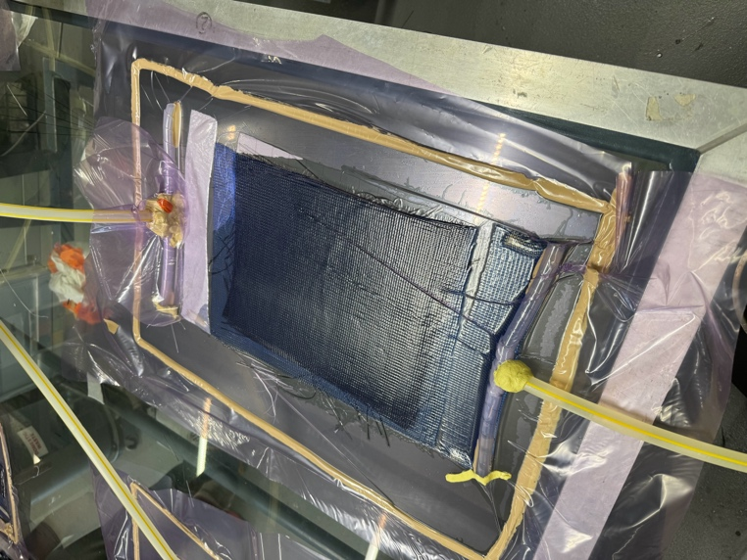

Vacuum Pump

Resin Source

The setup for forming the carbon fibre is as shown to the right. The procedure is as follows:

* The glass table is prepped with two coats of a solution to allow the full setup to be released in the end.
* The CF ensemble is placed onto the table.
* The plastic bag is placed ontop.
* The “barrels” and pipes are installed (holes in the bag needed.
* The plastic bag is sealed to the table, and the hoses are sealed to the barrels.
* The vacuum is applied.
* The resin is mixed and ‘ingested’.
* The resin hardens mostly in 2 hours but takes about ½ - 1 days to get fully hard.
* The setup is released.

This particular setup is much more variable than that of an autoclave, the temperature and humidity of the lab can’t be controlled so the climate impacts the result. Additionally, there is a lot more room for operator variability (skill of lab demo) effecting the results. A lot of resin is also wasted here (remember that 1.9x multiplier), mostly inside the hose and in the space outside of CF but inside the bag. Also the bag, hoses and sealant all need to be disposed of which is very wasteful.